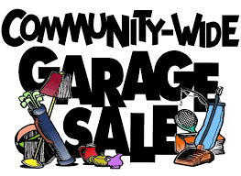
1st Annual Niskayuna Reformed Church Garage Sale
Saturday, May 12th, 2018
9am – 4pm
Various vendors from the community will be selling their goods.
Food will be sold by local business, Ario’s Pizza.

Cost: $2 admission for parking
Vendors: You can reserve a 20x20 foot outdoor spot with full payment of $20 if received by April 26, 2018. Reservations after April 26, 2018 will be $25. No tables are supplied. You must bring your own. Same day setup and takedown.
Call (518) 785-5575 for more information

